A Message from the Board of Directors

On July 23, for the full day, we will be offering a virtual class on the 2015 IFC and IBC Hazardous Materials Provisions. It will be taught by the ICC, so this is a great way to get Preferred Provider CEU’s. Morning and afternoon breaks, as well as a one-hour lunch period, will be built into the presentation.

The 2015 IFC and IBC Hazardous Materials Provisions seminar will address requirements for buildings utilizing hazardous materials and requiring coordination between the fire and building codes. It reviews the requirements found in Chapters 50 through 67 of the International Fire Code® (IFC®), as well as Chapter 3, and Sections 414 and 415 of the International Building Code® (IBC®).

Goal: The goal of this seminar is for participants to examine the application of code requirements in the 2015 IFC and the 2015 IBC to determine compliance for the storage use, handling and dispensing of hazardous materials.
The following publication is recommended to ensure success in the course:
- 2015 International Building Code® (IBC®)
- 2015 International Fire Code® (IFC®)

You can register on the IFIA website. Information on what will be covered in the class is listed above. The fee for IFIA member departments is $50, for non-members the fee is $75. The fee is per person. This is discounted from our typical $95 and $150 fee. If multiple people will be viewing from one computer, or protector, the add those names in when you register. That will be the only way for certificates to be issued by the ICC.

Save the Dates: for a virtual Fire Sprinkler 101 class on August 27 & 28, 2020. Each class will be from 0830 – Noon. There will be no charge for this class. We are going back to the basics. Day one will cover the fundamentals, and day two will build on that information. See the attachment for more details. Registration information will be out soon.

Taking in consideration social distancing requirements, we are offering Fire Inspector 1 and 2 classes in New Lenox. Inspector I begins on July 30, and Inspector II starts on October 1. Registration can be done on our website. As there are still some uncertainties, we will be holding off on any billing until about a month out from the class.

The Fire and Life Safety Educator class will be offered in May of 2021 at Downers Grove. Hopefully, we will be in a next phase for people meeting. If you might be interested in this class, let the IFIA office know by signing an interest form on the website so we can plan accordingly. As more details are finalized, we will let you know. If you desire a Basic Fire Prevention Officer certification from the OSFM, this class is needed.

The IFIA has two bookcases full of NFPA, IFSTA, Delmar, Jones and Bartlett, and Thompson books that we are looking to get rid of to free up some space. Some of these are current editions, some only one edition old, and some quite old – going back to the 80s. While the majority are fire related, there are many EMS books.

The cost of the books starts at $3. If you are interested in any of these books, arrangements can be made to pick them up at the office. If desired, we can ship them to you, with the only additional cost being whatever the shipping fee is.

We’ve done our best to indicate if this book is current or one edition old, but if that is a factor for you, do your diligence to confirm that information.

Pass this on to anyone you think might have an interest, including EMS personnel. When possible, we bundled books together such as workbooks and manuals, and manuals and instructor guides.

Restructuring at NFPA. We just received notice of some changes to us at NFPA. After 25 years as NFPA Regional Director, Russ Sanders is assuming the role of Executive Secretary of the Metropolitan “Metro” Fire Chiefs Association and liaison to several other key fire and international organizations

Meredith Hawes will take over the regional director’s duties in the north central region, which includes Illinois. While continuing her public education duties, Meredith will now be your direct contact for all NFPA tools and resources including NFPA codes and standards, training, certification, Fire Prevention Week, Fire Sprinkler Initiative state coalitions, and other key programs.

While not everything is worked out at this point, we are still looking for some type of a Fire Prevention Awards luncheon on September 25th. While that is still a few months away, NOW is the time to submit people to be recognized. There is no question that some of your people have gone above and beyond in fire prevention and/or fire and life safety activities – especially in this crazy time we are in. This is your chance to showcase your people for their efforts. A list of awards, and the nomination form, can be found on our website.

From the American Wood Council: We have set up a website to educate firefighters on wood construction and engineered wood products. The website is https://www.woodaware.info/

We are looking for feedback on how to make the site better and include all of the information that the fire service needs.

Please review the website and the materials and take this short survey (a link to the survey is also on the top tab) https://www.surveymonkey.com/r/WoodAware

Raymond O’Brocki, CBO
Manager- Fire Service Relations
AMERICAN WOOD COUNCIL
222 Catoctin Circle SE, Suite 201, Leesburg, VA 20175
Phone: 410-299-9681
Email: ROBrocki@awc.org

Note the attached ICC monthly update.

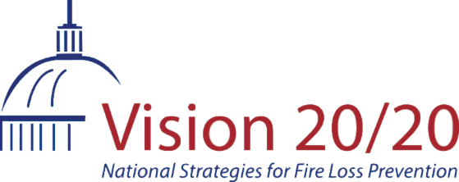

The Vision 20/20 CRR Materials Generator is launching a series of new social media-ready animations that you can download and use on your own Facebook, Twitter, Instagram and LinkedIn accounts.

All are open captioned, so the captioning is always present, which is great for social media channels and also makes them accessible for people that are deaf/hard-of-hearing.

We also are including suggested messaging that you can use with these animations when posting them.

These animations include...
- Why every home needs working smoke alarms
- Where to put your alarms
- What your smoke alarm sounds mean
- Proper smoke alarm maintenance
- What to do when there's a fire
- How to prevent falls for older adults

Download these, and other free resources, from the
Vision 20/20 CRR Materials Generator

Click here for the CRR Materials Generator

View one of the animations on YouTube, Every Home Needs Working Smoke Alarms

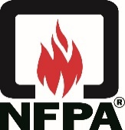 | 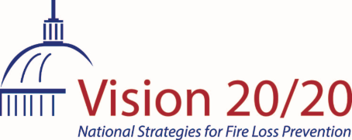 | 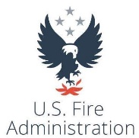

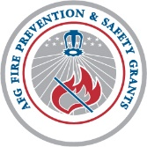
These animations were funded through a grant from the FEMA AFG Fire Prevention and Safety Grant program and developed in a partnership between Vision 20/20, the National Fire Protection Association and the United States Fire Administration.

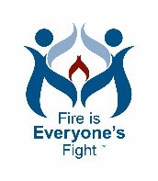
Stop by The Vision 20/20 Project's website for the latest resources and tools that you can use in your community and department.
www.strategicfire.org

‌ ‌

Visit our website

The following are the latest recalls from the Consumer Products Safety Commission:
Ushio America Recalls Indiglow LED T8 Lamps Due to Injury Hazard: https://www.cpsc.gov/Recalls/2020/Ushio-America-Recalls-Indiglow-LED-T8-Lamps-Due-to-Injury-Hazard
Island Wear Recalls Strollers Due to Violation of Federal Stroller and Carriage Safety Standard; Fall and Choking Hazards: https://www.cpsc.gov/Recalls/2020/Island-Wear-Recalls-Strollers-Due-to-Violation-of-Federal-Stroller-and-Carriage-Safety-Standard-Fall-and-Choking-Hazards
DICK’S Sporting Goods Recalls Safety Ropes Due to Fall and Injury Hazards: https://www.cpsc.gov/Recalls/2020/DICKS-Sporting-Goods-Recalls-Safety-Ropes-Due-to-Fall-and-Injury-Hazards
Bonnsu Recalls Miniware Teething Spoons Due to Choking Hazard: https://www.cpsc.gov/Recalls/2020/Bonnsu-Recalls-Miniware-Teething-Spoons-Due-to-Choking-Hazard
Edwards Recalls Mechanical Heat Detectors Due to Failure to Alert to Fire: https://www.cpsc.gov/Recalls/2020/Edwards-Recalls-Mechanical-Heat-Detectors-Due-to-Failure-to-Alert-to-Fire
Republic Wireless Recalls Relay Charging Cables Due to Overheating and Burn Hazards: https://www.cpsc.gov/Recalls/2020/Republic-Wireless-Recalls-Relay-Charging-Cables-Due-to-Overheating-and-Burn-Hazards
Rexair Recalls to Repair Rainbow SRX Vacuums Due to Fire and Burn Hazards: https://www.cpsc.gov/Recalls/2020/Rexair-Recalls-to-Repair-Rainbow-SRX-Vacuums-Due-to-Fire-and-Burn-Hazards
HON Recalls Office Chairs Due to Fall Hazard: https://www.cpsc.gov/Recalls/2020/HON-Recalls-Office-Chairs-Due-to-Fall-Hazard
Lochinvar Recalls Condensing Residential Boilers Due to Risk of Carbon Monoxide Poisoning: www.cpsc.gov/Recalls/2020/Lochinvar-Recalls-Condensing-Residential-Boilers-Due-to-Risk-of-Carbon-Monoxide-Poisoning
The Furniture Connexion Recalls Modavari Forrest Live Edge Benches Due to Fall and Injury Hazards: https://www.cpsc.gov/Recalls/2020/The-Furniture-Connexion-Recalls-Modavari-Forrest-Live-Edge-Benches-Due-to-Fall-and-Injury-Hazards

Check the website for the following upcoming events:
July & August – summer break for routine monthly meetings.
July 30, August 6, 13, 20, 27 Inspector 1, New Lenox
Aug 27 & 28 - Sprinkler basics ½ day each
Sept 25 – Awards luncheon at Plainfield FPD
October 1, 8, 15, 22, 29 Inspector 2, New Lenox
Oct 23 - kitchen systems sem and meeting
Nov 20 - Did You Know sem and meeting
Feb 17 - school safety round table full day
March 24 – 26 Annual Fire and Life Safety Conference
May 3-5, 10 and 11– Fire and Life Safety Educator – Downers Grove

